### **Task 6**

### Steps to Create a Cloud Account (AWS Example)

1. Go to [AWS Free Tier](https://aws.amazon.com/free/)
2. Click on **Create an AWS Account**.
3. Enter:
   * Email
   * Password
   * AWS account name
4. Provide:
   * Personal details
   * Payment details (AWS requires a credit/debit card for verification, but free-tier services won’t charge unless limits are exceeded).
5. Complete identity verification via OTP.
6. Choose a support plan (**Free-tier**).
7. Log in to the AWS Management Console.

### Capture Screenshot

* Once logged in, take a screenshot of the AWS Console (or chosen cloud provider’s dashboard).

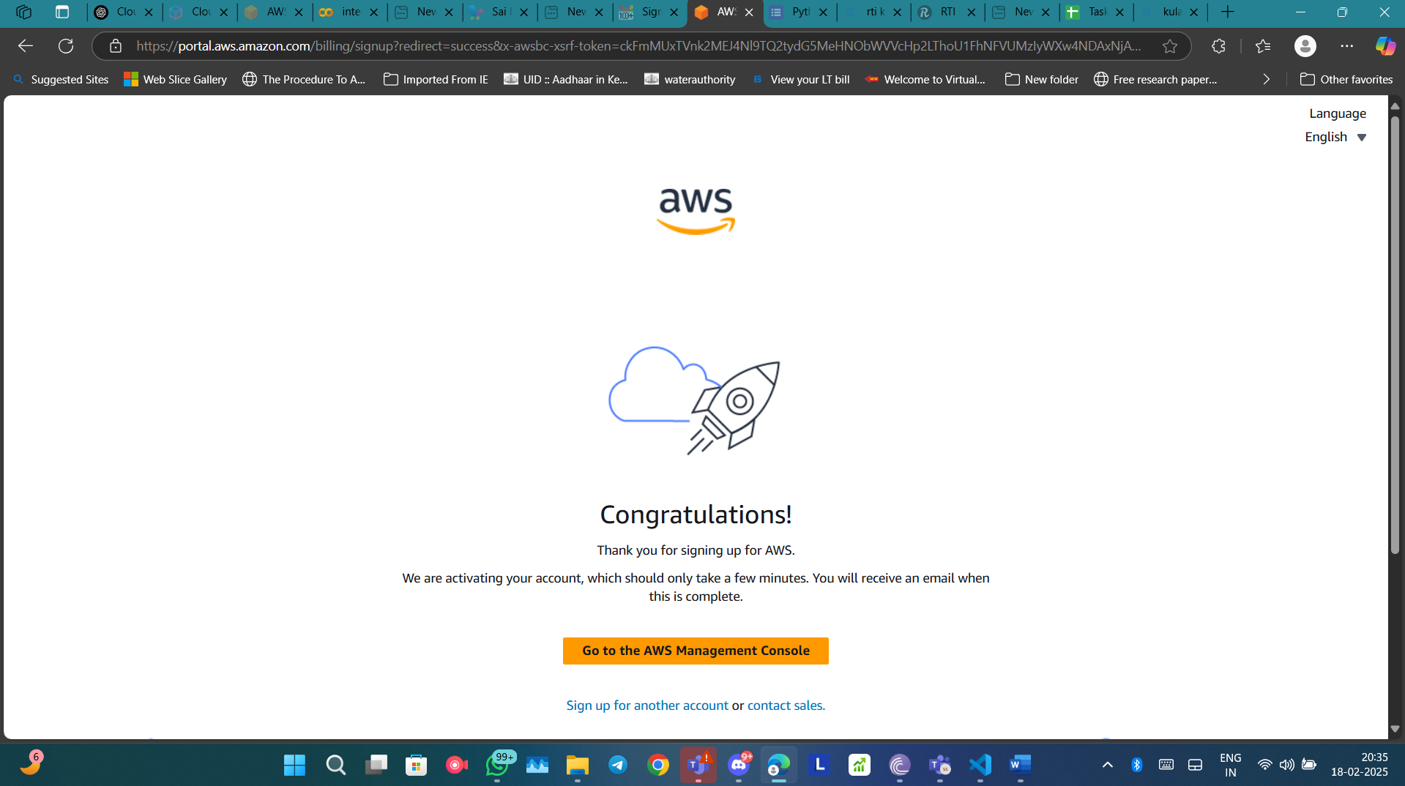

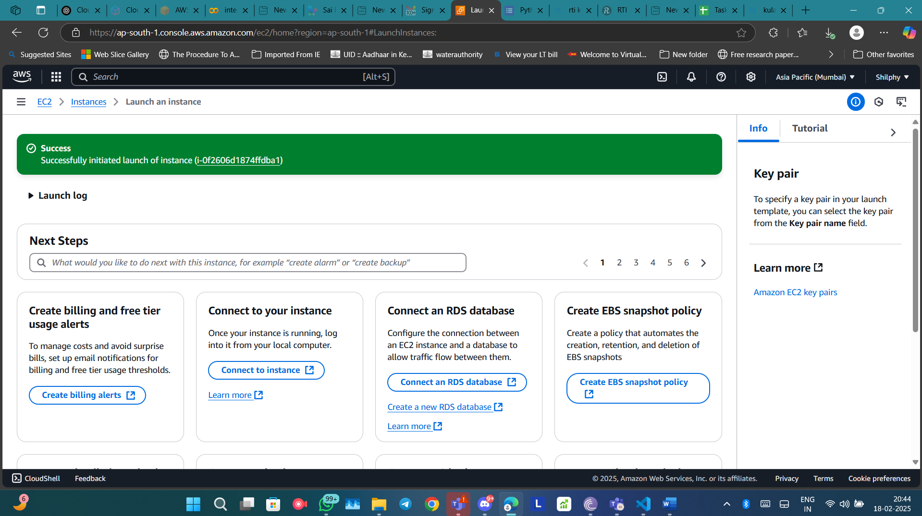

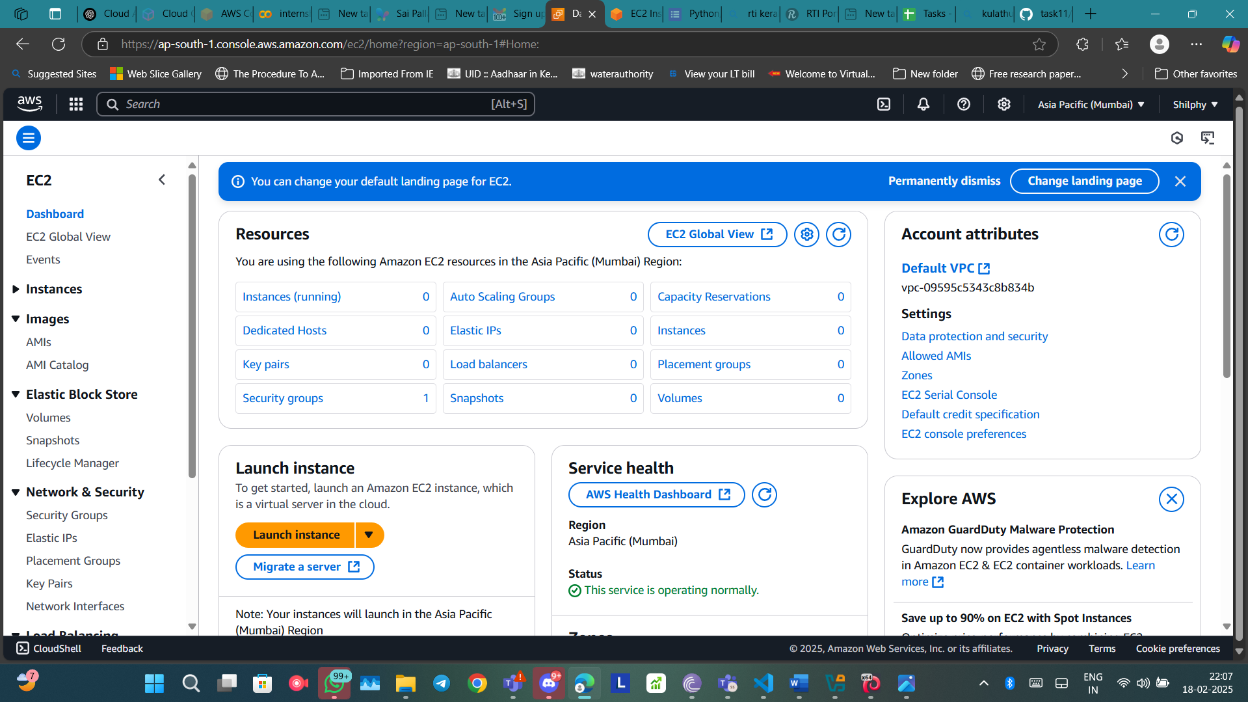

### **Task 11**

### **Step 1: Create a Free Virtual Machine (VM) in AWS**

1. **Login to AWS Console**: Go to [AWS Console](https://aws.amazon.com/) and sign in.
2. **Go to EC2 Service**:
   * Click on **Services** → **EC2** (Elastic Compute Cloud).
3. **Launch a Free-Tier VM**:
   * Click **Launch Instance**.
   * Choose **Amazon Linux 2** (or Ubuntu, if preferred).
   * Select **t2.micro** (which is free-tier eligible).
   * Configure network settings:
     + Allow SSH (port 22).
     + Enable ICMP (for ping) if needed.
   * Create a new key pair or use an existing one.
   * Click **Launch**.

### **Step 2: Find the IP Address of Your VM**

1. **Go to EC2 Dashboard** → **Instances**.
2. **Copy the Public IP Address** from the instance details.

### **Step 3: Ping the VM from Kali Linux**

1. Open **Kali Linux terminal**.
2. Run:

ping <your-public-ip>

1. If the ping fails, **modify security group settings**:
   * Go to **EC2 > Security Groups**.
   * Edit inbound rules.
   * Add a rule:
     + **Type:** ICMP (IPv4)
     + **Source:** Anywhere (0.0.0.0/0)
2. Try pinging again. **Take a screenshot**.

### **Step 4: SSH into the VM**

1. Open **Kali Linux terminal**.
2. Navigate to the key file (if needed).
3. Run:

ssh -i your-key.pem ec2-user@<your-public-ip>

1. Once logged in, run:

ip a

1. **Take a screenshot**.

### **Step 5: Ping Public IP from VM**

1. Inside the SSH session of your VM, run:

ping <your-public-ip>

1. If successful, **take a screenshot**.

### **Step 6: Explore and Shutdown the VM**

1. Check system info:

uname -a

1. Shut down the VM:

sudo shutdown -h now

* + Alternatively, stop it from **AWS EC2 Dashboard**.

### **Step 7: Terminate the VM**

1. Go to **EC2 Dashboard**.
2. Select your VM.
3. Click **Actions → Instance State → Terminate**.

### **Step 8: Upload Files to GitHub**

1. Create a repository named **task11** in GitHub.
2. Upload:
   * **Text file** with the steps.
   * **3 Screenshots** (Ping from Kali, SSH ip a, Public IP ping).
3. Push the changes.

